# VISVESVARAYA TECHNOLOGICAL UNIVERSITY

## BELAGAVI – 590018, Karnataka INTERNSHIP REPORT

### ON

**“Sentiment Analysis of Lockdown In USA During Covid-19 A Case Study On Twitter using ML”**

***Submitted in partial fulfilment for the award of degree(18CSI85)***

## BACHELOR OF ENGINEERING

**IN**

## INFORMATION SCIENCE ENGINEERING

***Submitted by:***

### N NAMAN KUMAR 1AM20IS055

Conducted at

### VARCONS TECHNOLOGIES



**AMC ENGINEERING COLLEGE**

**18thK.M. Bannerghatta Main Road, Bengaluru-560083**.

# AMC ENGINEERING COLLEGE

**Department of Information Science and Engineering**

**18thK.M. Bannerghatta Main Road, Bengaluru-560083**



**CERTIFICATE**

This is to certify that the Internship titled **“Sentiment Analysis Of Lockdown In USA During Covid-19 A Case Study On Twitter using ML”** carried out by **MR. N NAMAN KUMAR,** a bonafide student of AMC Engineering College in partial fulfillment for the award of **Bachelor of Engineering**, in **INFORMATION SCIENCE AND ENGINEERING** under Visvesvaraya Technological University, Belagavi, during the year 2022- 2023. It is certified that all corrections/suggestions indicated have been incorporated in the report.

The project report has been approved as it satisfies the academic requirements in respect of Internship prescribed for the course Internship / Professional Practice (18CSI85)

### Signature of Guide Signature of HOD Signature of Principal

**External Viva:**

Name of the Examiner Signature with Date

1)

2)

# D E C L A R A T I O N

I, **N NAMAN KUMAR**, final year student of ISE, AMC Engineering College

declare that the Internship has been successfully completed, in **VARCONS TECHNOLOGIES**. This report is submitted in partial fulfillment of the requirements for award of Bachelor Degree in Information Science and Engineering, during the academic year 2022-2023.

Date : 20th September 2023

Place : Bangalore

USN : 1AM20IS055

NAME : N NAMAN KUMAR

**OFFER LETTER**

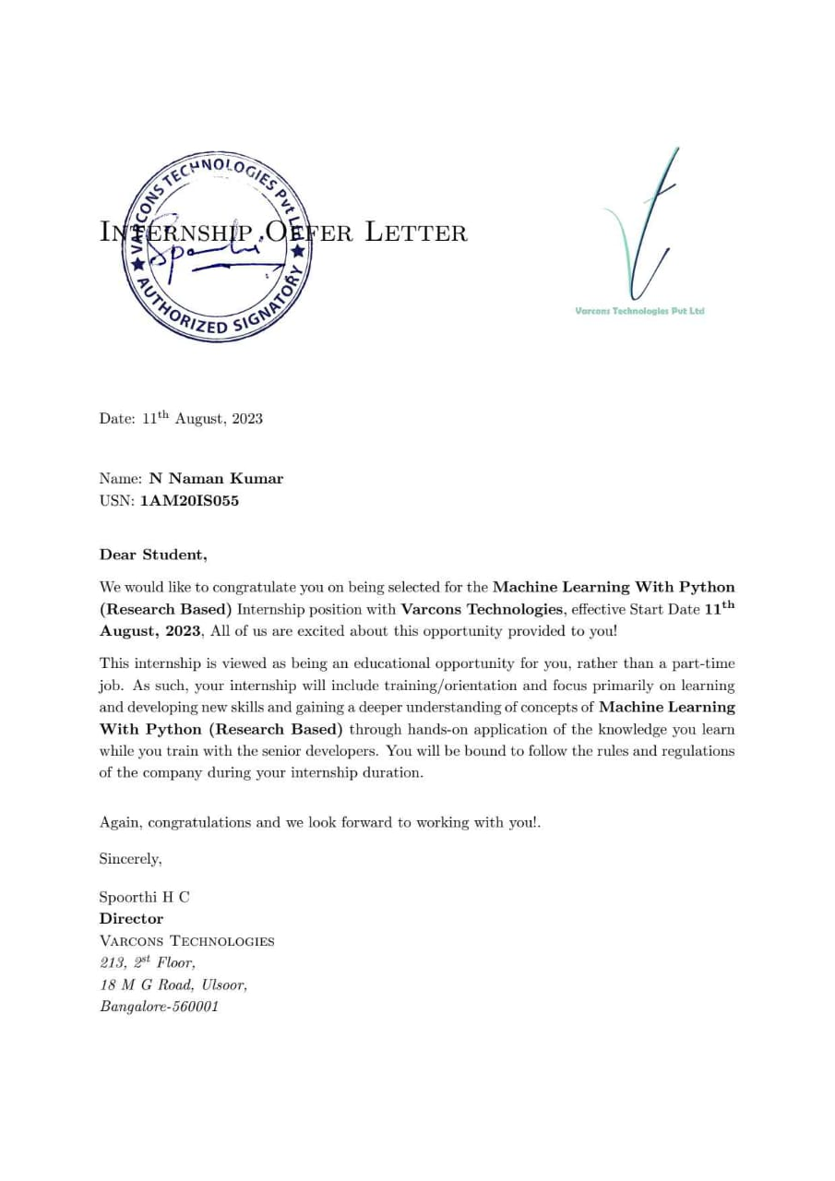

# A C K N O W L E D G E M E N T

This Internship is a result of accumulated guidance, direction and support of several important persons. I take this opportunity to express our gratitude to all who have helped us to complete the Internship.

I express my sincere thanks to our Principal Dr. Nagaraja, for providing us adequate facilities to undertake this Internship.

I would like to thank our Head of Dept – Dr. Terence Johnson, for providing us an opportunity to carry out Internship and for his valuable guidance and support.

I would like to thank our Software Services for guiding us during the period of internship.

I express my deep and profound gratitude to our guide, Guide name, Assistant/Associate Prof, for her keen interest and encouragement at every step in completing the Internship.

I would like to thank all the faculty members of our department for the support extended during the course of Internship.

I would like to thank the non-teaching members of our dept, for helping us during the Internship.

Last but not the least, I would like to thank our parents and friends without whose constant help, the completion of Internship would have not been possible.

**N NAMAN KUMAR 1AM20IS055**

# ABSTRACT

Unprecedented difficulties were brought about by the Covid-19 epidemic, including the need for lockdowns to stop the virus' transmission. The lockdown measures put in place in USA in 2020 had a significant impact on people's daily life. This study employs machine learning to analyze Twitter data in order to comprehend the mood of the USA populace during the lockdown.

Twitter serves as a rich source of current information and opinions as a microblogging platform. This case study uses machine learning and natural language processing (NLP) to glean important information from a vast corpus of tweets sent out during the USA lockdown. The study is driven by the need to assess public opinion, which is essential for understanding and formulating policy. The methodology entails the gathering, preprocessing, classification, and analysis of data. We gathered a wide range of tweets about the shutdown in USA during the Covid-19 pandemic. The data was cleaned using text preprocessing methods such tokenization, stop-word removal, and stemming. Different machine learning models, such as Support Vector Machines (SVM), Naive Bayes, and Recurrent Neural Networks (RNNs), were used for sentiment analysis. The findings of this study provided insight into the attitudes that prevailed during the lockdown. We divided tweets into three categories: favorable, negative, and neutral. The analysis showed the changing mood patterns over time, the major issues that attracted public interest, and the psychological effects of the lockdown on USA society. Governments and policymakers must comprehend these mood dynamics in order to make wise choices and address public issues in a timely manner. By proving the relevance of machine learning techniques in collecting the nuanced opinions expressed on social media platforms during a crisis, this research also contributes to the broader field of sentiment analysis. It demonstrates Twitter's potential as a useful data source for tracking public opinion and determining how people react to unusual situations. As a result, this case study offers important perceptions into how the USA populace felt during the Covid-19 lockdown, providing a data-driven understanding of how individuals reacted to this novel circumstance. The conclusions have repercussions for public policy, crisis management, and the creation of efficient communication plans for crisis situations.

# Table of Contents

|  |  |  |
| --- | --- | --- |
| **Sl no** | **Description** | **Page no** |
| 1 | Company Profile | 08 |
| 2 | About the Company | 10 |
| [3](https://1.bp.blogspot.com/-dODuK8N5h1Q/Wlnyb3V9HFI/AAAAAAAACL4/WxQtCJ1pM5wccDABg4wIrTBUB0vlikXQQCLcBGAs/s1600/poly1.jpg) | Introduction | 12 |
| [4](https://1.bp.blogspot.com/-dODuK8N5h1Q/Wlnyb3V9HFI/AAAAAAAACL4/WxQtCJ1pM5wccDABg4wIrTBUB0vlikXQQCLcBGAs/s1600/poly1.jpg) | System Analysis | 15 |
| [5](https://1.bp.blogspot.com/-dODuK8N5h1Q/Wlnyb3V9HFI/AAAAAAAACL4/WxQtCJ1pM5wccDABg4wIrTBUB0vlikXQQCLcBGAs/s1600/poly1.jpg) | Requirement Analysis | 17 |
| 6 | Design [Analysis](https://4.bp.blogspot.com/-IOOxgPaXMVc/Wlj3LWvcnjI/AAAAAAAACKE/UeTFYvAxDmUDel5UBjdifeWaApB3-dXVgCLcBGAs/s1600/img1.jpg) | 19 |
| 7 | [Implementation](https://4.bp.blogspot.com/-IOOxgPaXMVc/Wlj3LWvcnjI/AAAAAAAACKE/UeTFYvAxDmUDel5UBjdifeWaApB3-dXVgCLcBGAs/s1600/img1.jpg) | 23 |
| 8 | Snapshots | 25 |
| 9 | Conclusion | 28 |
| 10 | References | 30 |

[**CHAPTER**](https://1.bp.blogspot.com/-dODuK8N5h1Q/Wlnyb3V9HFI/AAAAAAAACL4/WxQtCJ1pM5wccDABg4wIrTBUB0vlikXQQCLcBGAs/s1600/poly1.jpg) **1 COMPANY PROFILE**

# COMPANY PROFILE

## A Brief History of Company

Company, was incorporated with a goal “To provide high quality and optimal Technological Solutions to business requirements of our clients”. Every business is a different and has a unique business model and so are the technological requirements. They understand this and hence the solutions provided to these requirements are different as well. They focus on clients requirements and provide them with tailor made technological solutions. They also understand that Reach of their Product to its targeted market or the automation of the existing process into e-client and simple process are the key features that our clients desire from Technological Solution they are looking for and these are the features that we focus on while designing the solutions for their clients.

Company is a Technology Organization providing solutions for all web design and development, MYSQL, PYTHON Programming, HTML, CSS, ASP.NET and LINQ. Meeting the ever increasing automation requirements, Sarvamoola Software Services. specialize in ERP, Connectivity, SEO Services, Conference Management, effective web promotion and tailor-made software products, designing solutions best suiting clients requirements.

we strive to be the front runner in creativity and innovation in software development through their well-researched expertise and establish it as an out of the box software development company in Bangalore, India. As a software development company, they translate this software development expertise into value for their customers through their professional solutions.

They understand that the best desired output can be achieved only by understanding the clients demand better. At our Company we work with them clients and help them to define their exact solution requirement. Sometimes even they wonder that they have completely redefined their solution or new application requirement during the brainstorming session, and here they position themselves as an IT solutions consulting group comprising of high caliber consultants.

They believe that Technology when used properly can help any business to scale and achieve new heights of success. It helps Improve its efficiency, profitability, reliability; to put itin one sentence ”Technology helps you to Delight your Customers” and that is what we want to achieve.

# [CHAPTER](https://1.bp.blogspot.com/-dODuK8N5h1Q/Wlnyb3V9HFI/AAAAAAAACL4/WxQtCJ1pM5wccDABg4wIrTBUB0vlikXQQCLcBGAs/s1600/poly1.jpg) 2 ABOUT THE COMPANY

1. **ABOUT THE COMPANY**

We are a Technology Organization providing solutions for all web design and development, Researching and Publishing Papers to ensure the quality of most used ML Models, MYSQL, PYTHON Programming, HTML, CSS, ASP.NET and LINQ. Meeting the ever increasing automation requirements, Varcons Technologies specialize in ERP, Connectivity, SEO Services, Conference Management, effective web promotion and tailor-made software products, designing solutions best suiting clients requirements. The organization where they have a right mix of professionals as a stakeholders to help us serve our clients with best of our capability and with at par industry standards. They have young, enthusiastic, passionate and creative Professionals to develop technological innovations in the field of Mobile technologies, Web applications as well as Business and Enterprise solution. Motto of our organization is to “Collaborate with our clients to provide them with best Technological solution hence creating Good Present and Better Future for our client which will bring a cascading a positive effect in their business shape as well”. Providing a Complete suite of technical solutions is not just our tag line, it is Our Vision for Our Clients and for Us, We strive hard to achieve it.

## Services provided by Varcons Technologies.

* Core Java and Advanced Java
* Research and Development/Improvise of ML Models
* Web services and development
* Dot Net Framework
* Python
* Selenium Testing
* Conference / Event Management Service
* Academic Project Guidance
* On The Job Training
* Software Training

# [CHAPTER](https://1.bp.blogspot.com/-dODuK8N5h1Q/Wlnyb3V9HFI/AAAAAAAACL4/WxQtCJ1pM5wccDABg4wIrTBUB0vlikXQQCLcBGAs/s1600/poly1.jpg) 3 INTRODUCTION

1. **INTRODUCTION**

## Introduction to ML

According to Christopher M. Bishop's book, machine learning, which enables computers to learn from data without explicit programming. It places a focus on extrapolating from historical data to create predictions about future, unforeseen data. Techniques include reinforcement learning (sequential decision-making), unsupervised learning (finding patterns in unlabeled data), and supervised learning (from labelled data). Building adaptive models is the goal, and applications include speech and image recognition, healthcare, finance, and more. Bishop's work offers a thorough grasp of the mathematical underpinnings, techniques, and applications of this discipline.

The capability of ML to examine and identify patterns in huge datasets is one of its core characteristics. Massive amounts of data can be fed into algorithms to reveal hidden information and produce precise forecasts or classifications. Due to this capability, ML has become a crucial tool for companies and researchers who want to extract useful information from their data and use it to influence decisions.

One of the most popular ML techniques is supervised learning, in which algorithms learn from labelled data to produce predictions or categorizations. Applications including image identification, natural language processing, and recommendation systems all frequently employ this technique. While unsupervised learning, which is essential for tasks like clustering and dimensionality reduction, entails algorithms recognizing patterns or structures in data without the need of labelled samples.

## Problem Statement

The Covid-19 pandemic had an influence on the entire world, forcing India to put in place vital lockdowns. These actions had a significant impact on people's life and had detrimental economic, social, and emotional effects. Lockdowns damaged businesses and way of life even if they were vital for the public's health. They caused social isolation and disruption, as well as difficulties with remote job and education. People struggled with anxiety and uncertainty on an emotional level. Understanding public opinion during these lockdowns is essential for policymakers and academics to plan for upcoming emergencies.

The pandemic highlights the need for flexible governance. Experiences with lockdowns have a significant impact on public opinion, which can be used to improve regulations. Strategies for crisis response that are more effective and humane can be developed by analyzing the various views of the Indian population. For USA to remain resilient in the future, learning from the pandemic and the public's reactions would be crucial.

# [CHAPTER](https://1.bp.blogspot.com/-dODuK8N5h1Q/Wlnyb3V9HFI/AAAAAAAACL4/WxQtCJ1pM5wccDABg4wIrTBUB0vlikXQQCLcBGAs/s1600/poly1.jpg) 4 SYSTEM ANALYSIS

1. **SYSTEM ANALYSIS**

## Existing System

A typical process in an existing system for sentiment analysis of Covid-19 lockdown-related tweets in USA includes data collection from Twitter, data preprocessing to clean and tokenize text, sentiment labelling, feature extraction, and the choice and training of a machine learning model for sentiment classification. Evaluation measures are used to gauge model performance, and the results are presented for review. The observations made by this approach can aid scholars and decision-makers in understanding how the public felt about the outbreak. Several tools and libraries might be utilized, depending on the most recent developments in sentiment analysis and natural language processing.

## Proposed System

The machine learning-based approach that is being recommended for sentiment analysis of the Covid-19 lockdown in USA on Twitter includes data collection, preprocessing, sentiment labelling, feature extraction, model selection, training, assessment, visualization, interpretation, and reporting. Its goal is to provide perspectives on how public opinion changed throughout the lockdown, assisting scholars and decision-makers in crisis management and public policy. Certain tools and libraries should be chosen based on the most recent developments in sentiment analysis.

## Objective of the System

1. Build a model to classify tweets as favorable, negative, or neutral to get a sense of how the public feels.
2. Track sentiment changes over time during various lockdown phases to identify changing public perceptions using temporal analysis.
3. Discover the Main Discussion Points About the Lockdown from Tweets to Understand What People Are Most Concerned About.
4. Geographical Analysis: Based on user location data, examine sentiment variances across various Indian areas.
5. Sentiment Drivers: Use feature importance analysis to identify the major variables affecting sentiment, revealing what actions or regulations have an impact on people's perceptions during the lockdown.

# [CHAPTER](https://1.bp.blogspot.com/-dODuK8N5h1Q/Wlnyb3V9HFI/AAAAAAAACL4/WxQtCJ1pM5wccDABg4wIrTBUB0vlikXQQCLcBGAs/s1600/poly1.jpg) 5 REQUIREMENT ANALYSIS

* 1. **REQUIREMENT ANALYSIS**

## Hardware Requirement Specification

* + Processor: I3/Intel
  + Processor RAM: 4GB (min)
  + Hard Disk: 128 GB
  + Key Board: Standard Windows Keyboard
  + Mouse: Two or Three Button Mouse
  + Monitor: Any

## Software Requirement Specification

* + Operating System: Windows 7+
  + Server-side Script: Python 3.6+
  + IDE: Jupyter Notebook
  + Libraries Used: Seaborn, Pandas etc.,

# [CHAPTER](https://1.bp.blogspot.com/-dODuK8N5h1Q/Wlnyb3V9HFI/AAAAAAAACL4/WxQtCJ1pM5wccDABg4wIrTBUB0vlikXQQCLcBGAs/s1600/poly1.jpg) 6 DESIGN ANALYSIS

* 1. **DESIGN & ANALYSIS**

Analysis of emotion on Twitter is necessary to comprehend public opinion during USA COVID-19 lockdown. This project will include data collecting, text preparation, and feature engineering. A lexicon or labelled dataset will be used to train sentiment classifiers, and the results will help policymakers and academics by providing crucial insights into the shifting sentiments and attitudes throughout this trying time.

### Step 1: Problem Definition

Define the issue you're trying to resolve:

Problem: To assess popular attitude and emotions, analyze the sentiment of tweets on the lockdown in USA during the COVID-19 outbreak.

### Step 2: Data Collection

Compile pertinent information for your analysis. Twitter Data: To gather tweets on the lockdown in USA, use the Twitter API or third-party tools like Tweepy. Utilize relevant hashtags or keywords to filter tweets

Sentiment Labels: To produce a labelled dataset for training and evaluation, manually classify a portion of the gathered tweets as positive, negative, or neutral.

### Step 3: Data Preprocessing

Make the data clean and ready: Text preprocessing: Remove from the tweets any noise, special characters, URLs, and emoticons. Split the text into words or tokens by using tokenization. Eliminate words like "and," "the," and "is" that are frequently used but don't convey any emotion.

Utilizing methods like TF-IDF (Term Frequency-Inverse Document Frequency) or word embeddings (such as Word2Vec, Glove), convert the text data into numerical vectors.

### Step 4: Model Selection

Select a suitable deep learning or machine learning model for sentiment analysis. Several possibilities are:

1. Logistic Regression
2. Naive Bayes
3. Support Vector Machines (SVM)
4. Recurrent Neural Networks (RNNs)
5. Convolutional Neural Networks (CNNs)

### Step 5: Model Training

Utilize the labelled dataset to train your chosen model. Create training, validation, and test sets from the data. Cross-validation methods can be used to adjust hyperparameters and avoid overfitting.

### Step 6: Model Evaluation

Utilize the right measures, such as accuracy, precision, recall, F1-score, and ROC-AUC, to assess the performance of your model. Adjust the model as needed.

### Step 7: Sentiment Analysis

Analyze the sentiment of the tweets in your dataset using the trained model. Predicting the sentiment labels (positive, negative, or neutral) for each tweet will be required.

### Step 8: Analysis and Visualization

Make your sentiment analysis' findings visible by using graphs, charts, and descriptive statistics. Find vital information by analyzing sentiment trends and patterns over time or by region.

### Step 9: Interpretation

Interpret your analysis's conclusions. What did the sentiment analysis tell you about the mood of the USA population during the lockdown? Exist any noteworthy trends or patterns?

### Step 10: Report and Presentation

Put your analysis together in a thorough report or presentation. Include the research process, data sources, findings, and conclusions. To make your findings more understandable, use charts and graphs to illustrate the sentiment trends.

### Step 11: Recommendations and Conclusion

Summarize the key findings in your study' conclusion, and then offer any advice or conclusions you were able to derive from the sentiment analysis.

### Step 12: Deployment (Optional)

Consider developing a web application or API to offer continuous sentiment analysis of tweets linked to the lockout if you intend to deploy this sentiment analysis system for real-time monitoring.

### Step 13: Continuous Improvement (Optional)

To keep your model current with shifting sentiments and trends, you need continually gather fresh data and retrain it.

# [CHAPTE](https://1.bp.blogspot.com/-dODuK8N5h1Q/Wlnyb3V9HFI/AAAAAAAACL4/WxQtCJ1pM5wccDABg4wIrTBUB0vlikXQQCLcBGAs/s1600/poly1.jpg)R 7 IMPLEMENTATION

**7. IMPLEMENTATION**

Implementation is the stage where the theoretical design is turned into a working system. The most crucial stage in achieving a new successful system and in giving confidence on the new system for the users that it will work efficiently and effectively.

The system can be implemented only after thorough testing is done and if it is found to work according to the specification. It involves careful planning, investigation of the current system and it constraints on implementation, design of methods to achieve the change over and an evaluation of change over methods a part from planning.

Two major tasks of preparing the implementation are education and training of the users and testing of the system. The more complex the system being implemented, the more involved will be the system analysis and design effort required just for implementation.

The implementation phase comprises of several activities. The required hardware and software acquisition is carried out. The system may require some software to be developed. For this, programs are written and tested. The user then changes over to his new fully tested system and the old system is discontinued.

## TESTING

The testing phase is an important part of software development. It is the Information zed system will help in automate process of finding errors and missing operations and also a complete verification to determine whether the objectives are met and the user requirements are satisfied. Software testing is carried out in three steps:

1. The first includes unit testing, where in each module is tested to provide its correctness, validity and also determine any missing operations and to verify whether the objectives have been met. Errors are noted down and corrected immediately.
2. Unit testing is the important and major part of the project. So errors are rectified easily in particular module and program clarity is increased. In this project entire system is divided into several modules and is developed individually. So unit testing is conducted to individual modules.
3. The second step includes Integration testing. It need not be the case, the software whose modules when run individually and showing perfect result.

# [CHAPTE](https://1.bp.blogspot.com/-dODuK8N5h1Q/Wlnyb3V9HFI/AAAAAAAACL4/WxQtCJ1pM5wccDABg4wIrTBUB0vlikXQQCLcBGAs/s1600/poly1.jpg)R 8 SNAPSHOTS

* 1. **SNAPSHOTS**

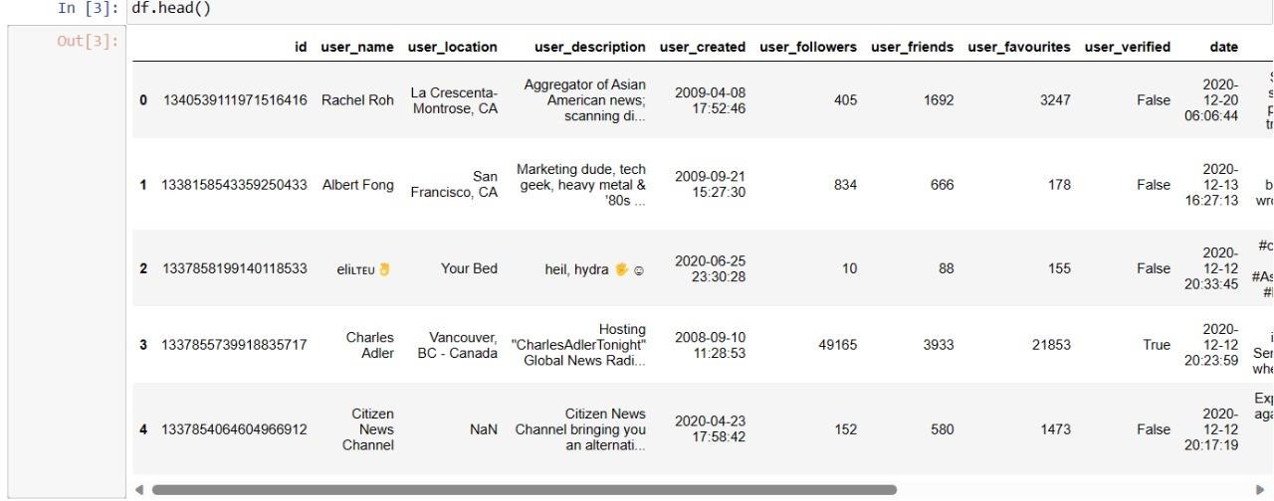

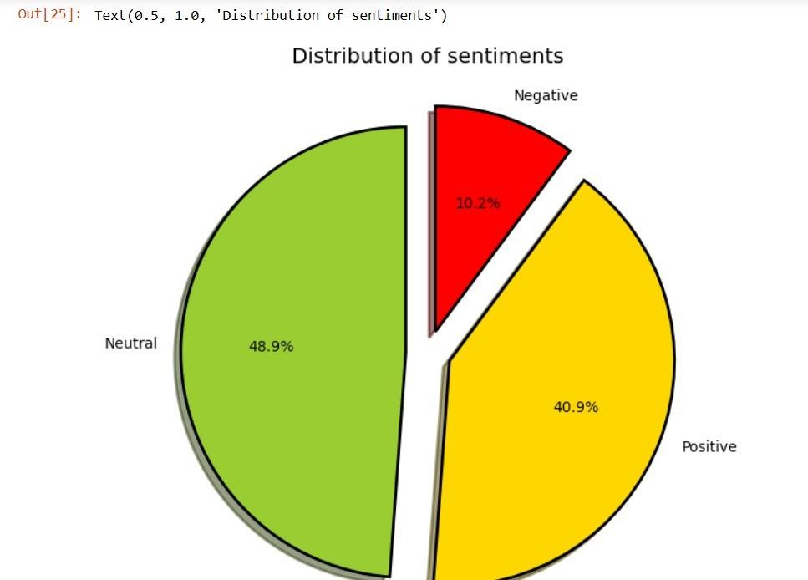

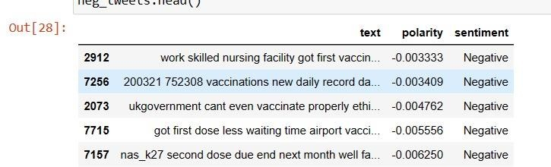

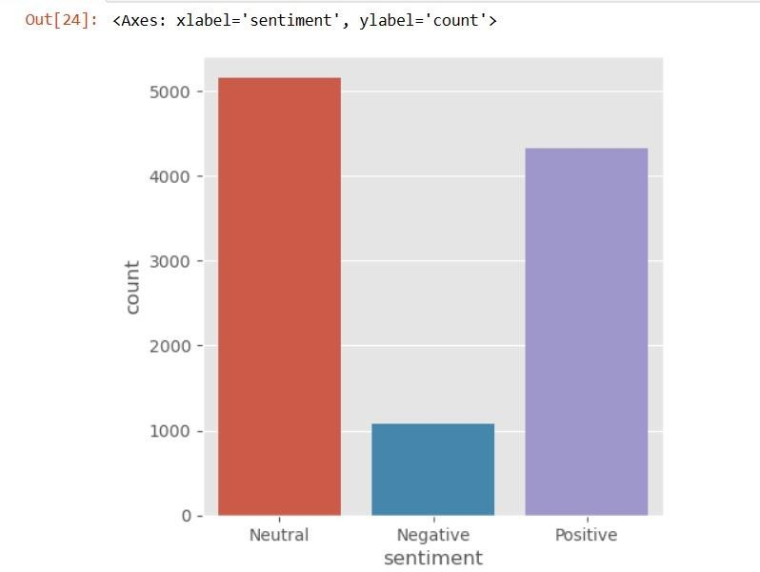

# [CHAPTE](https://1.bp.blogspot.com/-dODuK8N5h1Q/Wlnyb3V9HFI/AAAAAAAACL4/WxQtCJ1pM5wccDABg4wIrTBUB0vlikXQQCLcBGAs/s1600/poly1.jpg)R 9 CONCLUTION

* 1. **CONCLUTION**

The package was designed in such a way that future modifications can be done easily. The following conclusions can be deduced from the development of the project:

* Automation of the entire system improves the efficiency
* It provides a friendly graphical user interface which proves to be better when compared to the existing system.
* It gives appropriate access to the authorized users depending on their permissions.
* It effectively overcomes the delay in communications.
* Updating of information becomes so easier
* System security, data security and reliability are the striking features.
* The System has adequate scope for modification in future if it is necessary.

# [CHAPTE](https://1.bp.blogspot.com/-dODuK8N5h1Q/Wlnyb3V9HFI/AAAAAAAACL4/WxQtCJ1pM5wccDABg4wIrTBUB0vlikXQQCLcBGAs/s1600/poly1.jpg)R 10 REFERENCE

* 1. **REFERENCE**

1. P. Gupta, S. Kumar, R. R. Suman, and V. Kumar, “Sentiment analysis of lockdown in india during covid-19: A case study on twitter,” IEEE Transactions on Computational Social Systems, vol. 8, no. 4, pp. 992–1002, 2020.
2. C. Shofiya and S. Abidi, “Sentiment analysis on covid19-related social distancing in canada using twitter data,” International Journal of Environmental Research and Public Health, vol. 18, no. 11, p. 5993, 2021.
3. S. Liu and J. Liu, “Public attitudes toward covid-19 vaccines on english-language twitter: A sentiment analysis,” Vaccine, vol. 39, no. 39, pp. 5499–5505, 2021.
4. R. Chandra and A. Krishna, “Covid-19 sentiment analysis via deep learning during the rise of novel cases,” PLoS One, vol. 16, no. 8, p. e0255615, 2021.
5. S. Majumder, A. Aich, and S. Das, “Sentiment analysis of people during lockdown period of covid-19 using svm and logistic regression analysis,” Available at SSRN 3801039, 2021.
6. D. T. Huerta, J. B. Hawkins, J. S. Brownstein, and Y. Hswen, “Exploring discussions of health and risk and public sentiment in massachusetts during covid-19 pandemic mandate

implementation: A twitter analysis,” SSM-Population Health, vol. 15, p. 100851, 2021.

1. S. P. Nazare, P. S. Nar, A. S. Phate, and D. Ingle, “Sentiment analysis in twitter,” Int Res J Eng Technol (IRJET), vol. 5, 2018.
2. M. Ritonga, M. A. Al Ihsan, A. Anjar, F. H. Rambe et al., “Sentiment analysis of covid-19 vaccine in indonesia using naïve bayes algorithm,” in IOP Conference Series: Materials Science and Engineering, vol. 1088, no. 1. IOP Publishing, 2021, p. 012045.
3. K. Gandhe, A. S. Varde, and X. Du, “Sentiment analysis of twitter data with hybrid learning for recommender applications,” in 2018 9th IEEE Annual Ubiquitous Computing, Electronics & Mobile Communication Conference (UEMCON). IEEE, 2018, pp. 57–63.
4. J. Xue, J. Chen, R. Hu, C. Chen, C. Zheng, Y. Su, T. Zhu et al., “Twitter discussions and emotions about the covid-19 pandemic: Machine learning approach,” Journal of medical Internet research, vol. 22, no. 11, p. e20550, 2020.
5. V. K. Neppalli, C. Caragea, A. Squicciarini, A. Tapia, and S. Stehle, “Sentiment analysis during hurricane sandy in emergency response,” International journal of disaster risk reduction, vol. 21, pp. 213–222, 2017.
6. M. S. Al-Rakhami and A. M. Al-Amri, “Lies kill, facts save: detecting covid-19 misinformation in twitter,” Ieee Access, vol. 8, pp. 155 961–155 970, 2020.